Practical 1
Date - 22/7/25
Rainfall Tracking:
#include<iostream>

using namespace std;

void print(){
int rainfall[3][4];

for(int i=0;i<3;i++){
cout<<"\n";
for(int j = 0; j <4;j++){
cin>>rainfall[i][j];
}

}

for(int i=0;i<3;i++){
cout<<"\n";
for(int j = 0; j <4;j++){
cout<<rainfall[i][j];
cout<<"\t";

}
}
cout<<"\n";
int sum = 0;
int n;
cout<<"Enter city 0 - Pune, 1 - Mumbai, 2 - Kolkata";
cin>>n;
for(int j=0;j<4;j++){
sum = sum + rainfall[n][j];
}
cout<<"Average is :"<<sum/4;

}

int main(){
print();

return 0;

}
}

Output -
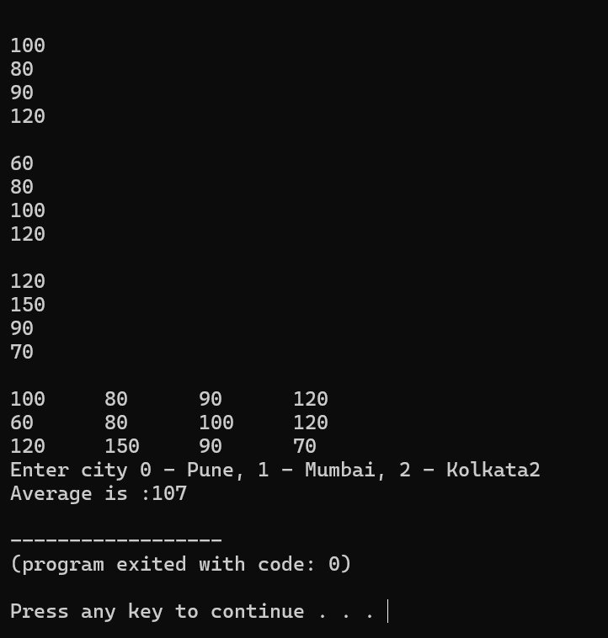

Temperature Tracker:
#include<iostream>

using namespace std;

void print(){
int rainfall[3][7];

for(int i=0;i<3;i++){
cout<<"\n";
for(int j = 0; j<7;j++){
cout<<"Enter temperature : ";
cin>>rainfall[i][j];
}

}

for(int i=0;i<3;i++){
cout<<"\n";
for(int j = 0; j<7;j++){
cout<<rainfall[i][j];
cout<<"\t";

}
}
cout<<"\n";
int sum = 0;
int n;
cout<<"Enter city 0 - Pune, 1 - Mumbai, 2 - Kolkata";
cin>>n;
for(int j=0;j<7;j++){
sum = sum + rainfall[n][j];
}
cout<<"Average is :"<<sum/7;

}

int main(){
print();

return 0;

}

OUTPUT -
